**Test Log:**

**1.Unit-Test**

**Unit-Test- 1**

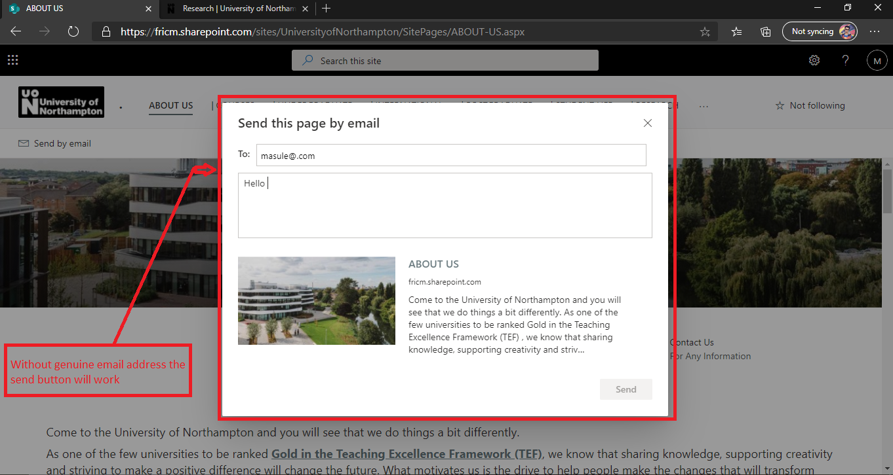

**Figure:**  fulfill the form with genuine email.

**Unit-Test - 2**

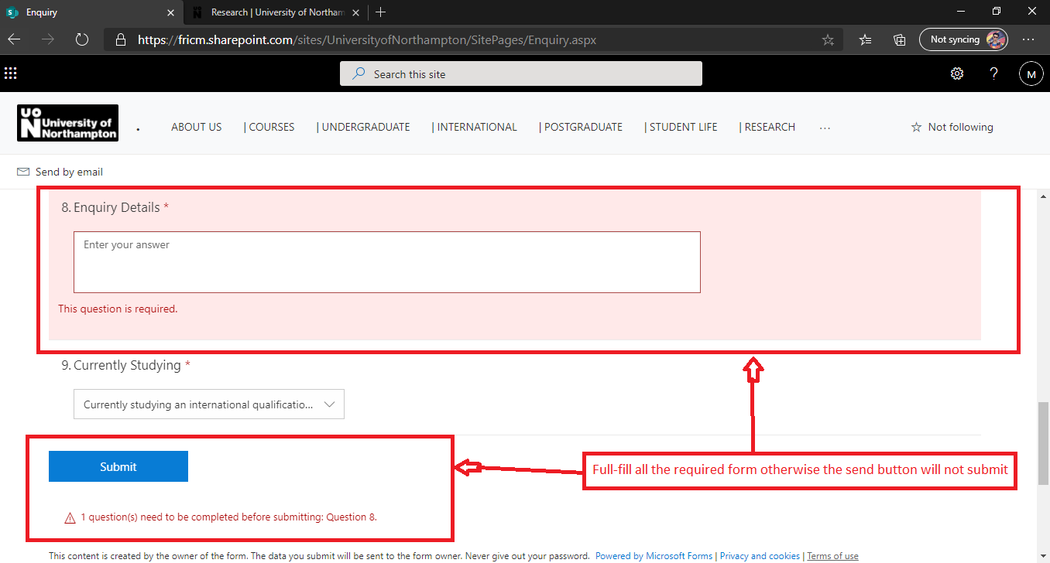

**Figure:**  Without fulfill the whole form there was a message to shown.

**Unit-Test - 3**

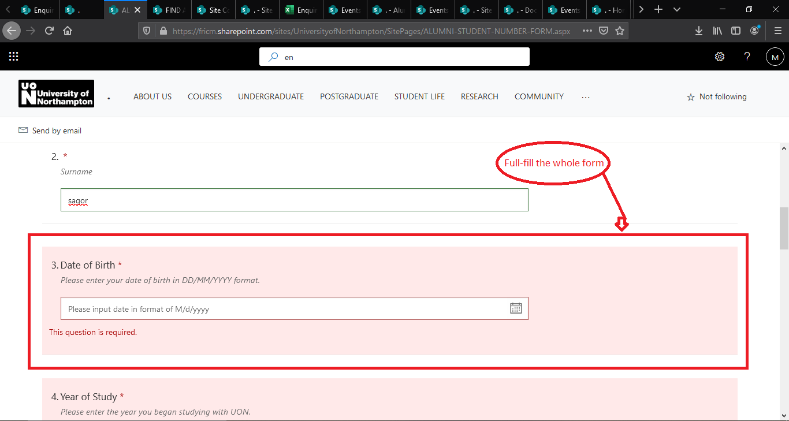

**Figure:**  Without fulfill the whole form it will not submit.

|  |  |  |  |  |  |
| --- | --- | --- | --- | --- | --- |
| **Test ID** | **Name of test** | **Description** | **Outcome** | **Actual Result** | **Result** |
| 1 | Unit-Test | How well the system cheek Validation of every form. | Checking the every possible Validation and it check correctly. | Without genuine email address and without full-fill the whole form the send and submit button have not submit | PASSED |

**2. Integration Test**

**Integration Test- 1**

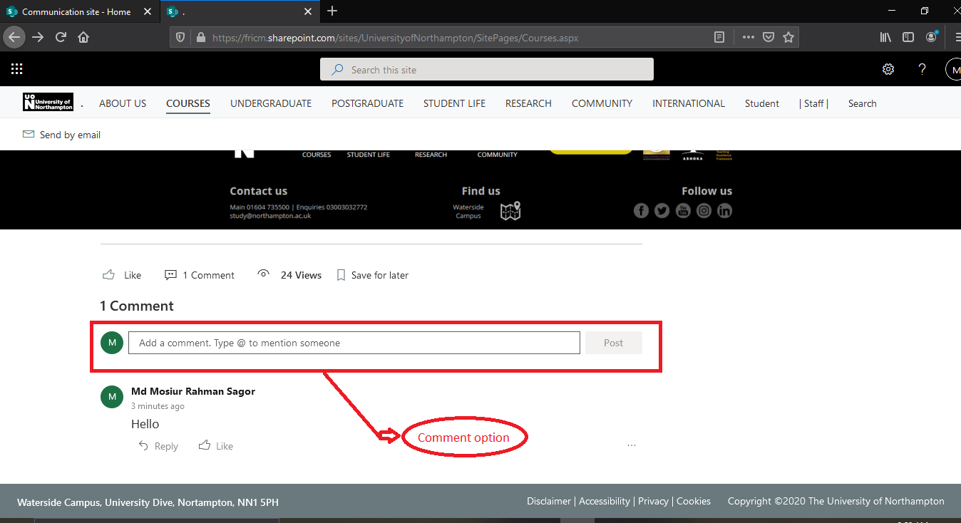

**Figure:**  In comment option post comments.

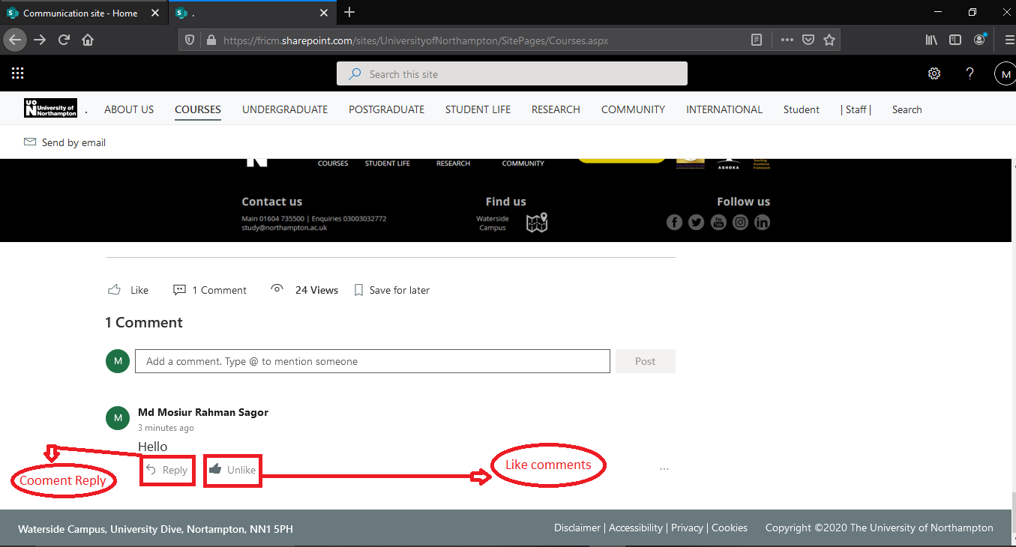

**Figure:**  comment can be like and reply comment.

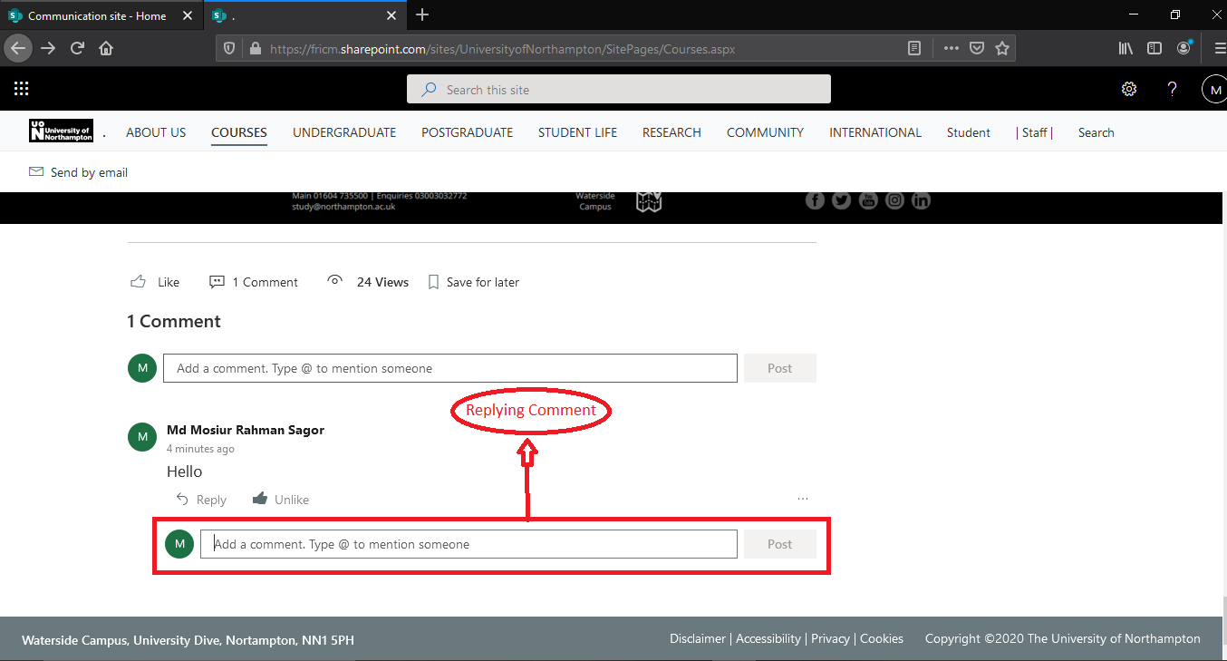

**Figure:**  Comment Reply in reply button.

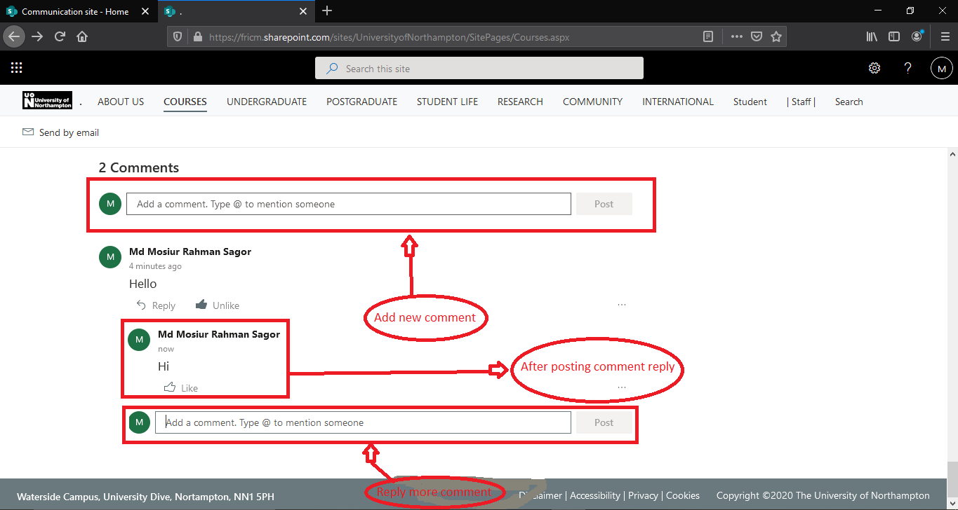

**Figure:**  After reply comment and can add new comment.

**Integration Test- 2**

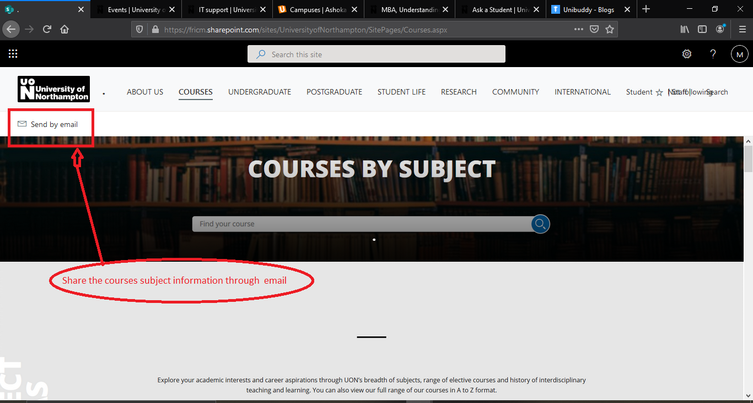

**Figure:**  Click the send by email for send email.

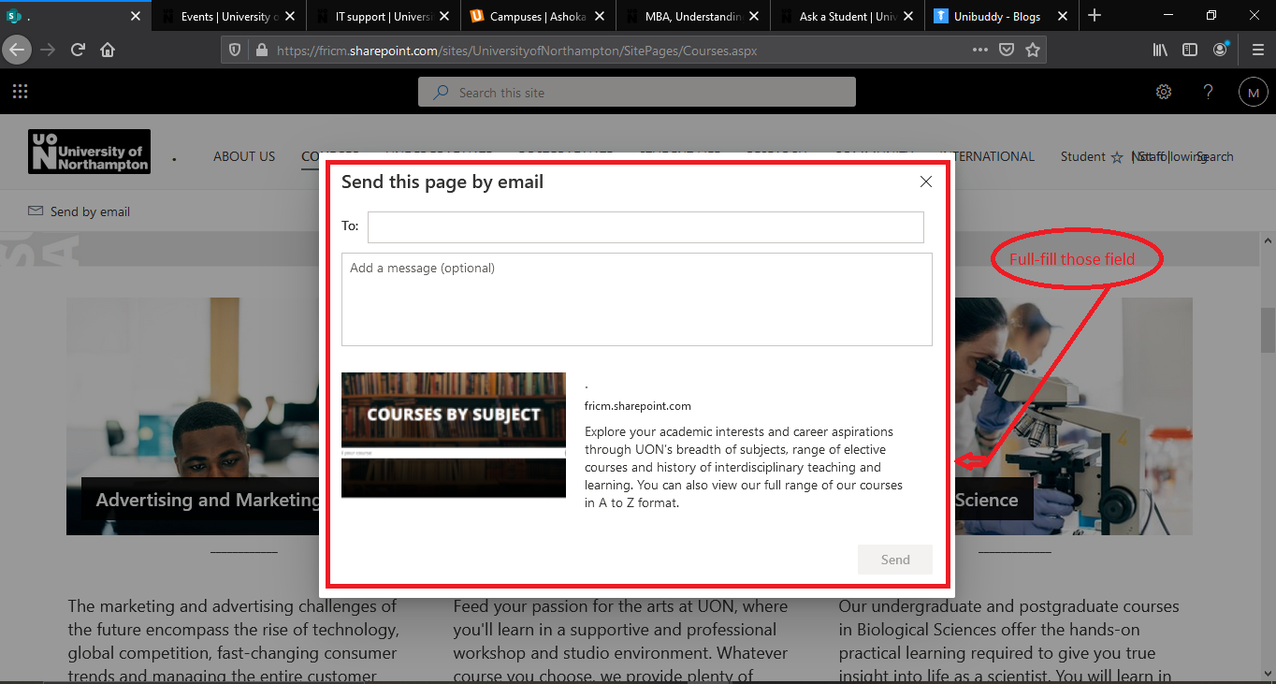

**Figure:**  full-full the entire field.

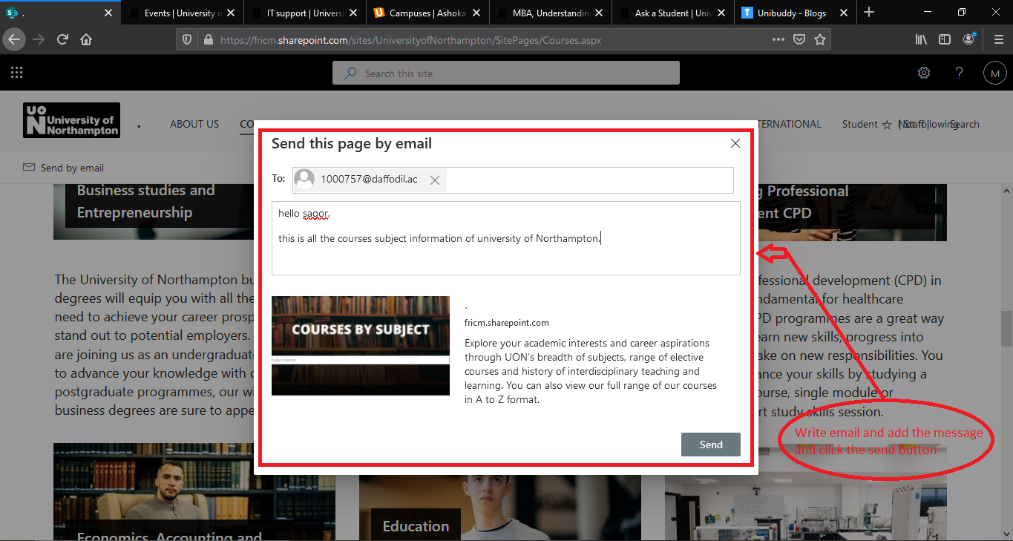

**Figure:**  After full-full the entire fields then click the send button.

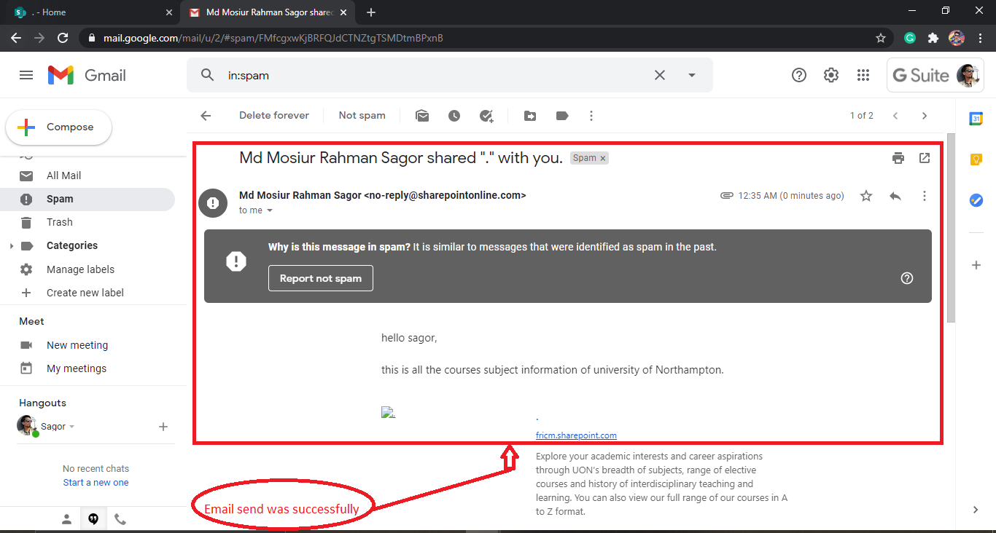

**Figure:**  Email sends successfully.

|  |  |  |  |  |  |
| --- | --- | --- | --- | --- | --- |
| **Test ID** | **Name of test** | **Description** | **Outcome** | **Actual Result** | **Result** |
| 2 | Integration test | How the Integration has work in the system | The response of the Integration was good. | Comment and like option has been added and also user can reply other comments. The share information has been found in email inbox. | PASSED |

**3. Functional Test**

**Functional Test- 1**

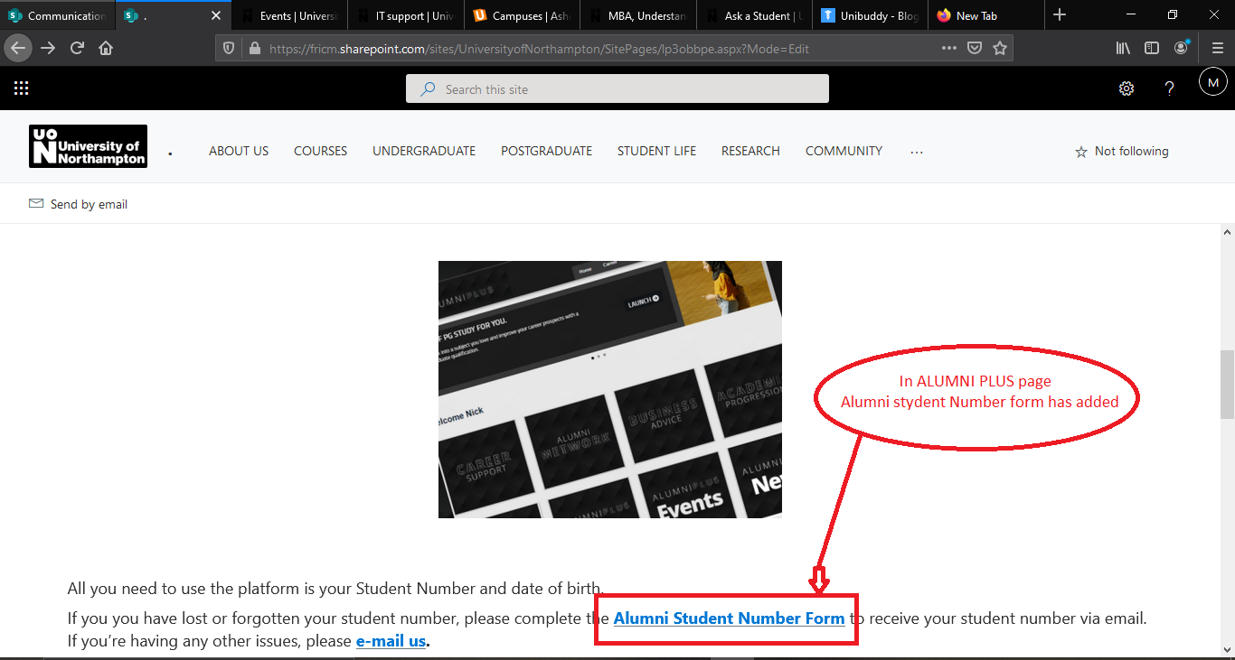

**Figure:**  Click the Alumni student number form

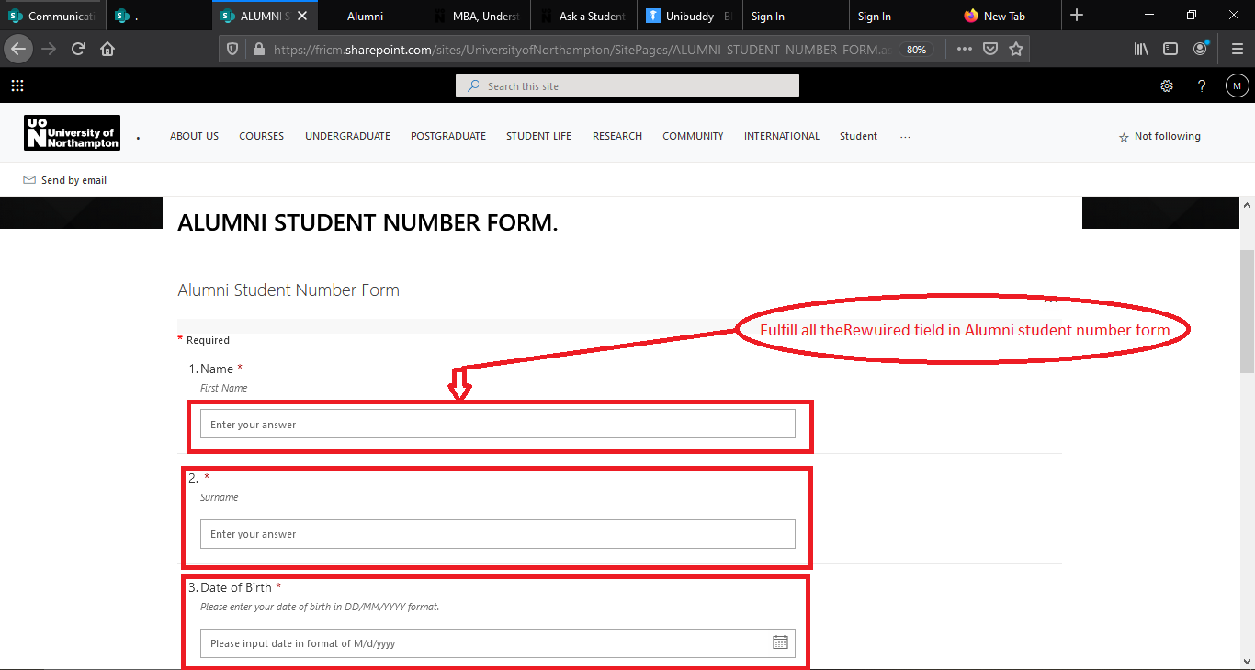

**Figure:**  Fulfill all the Requirements form.

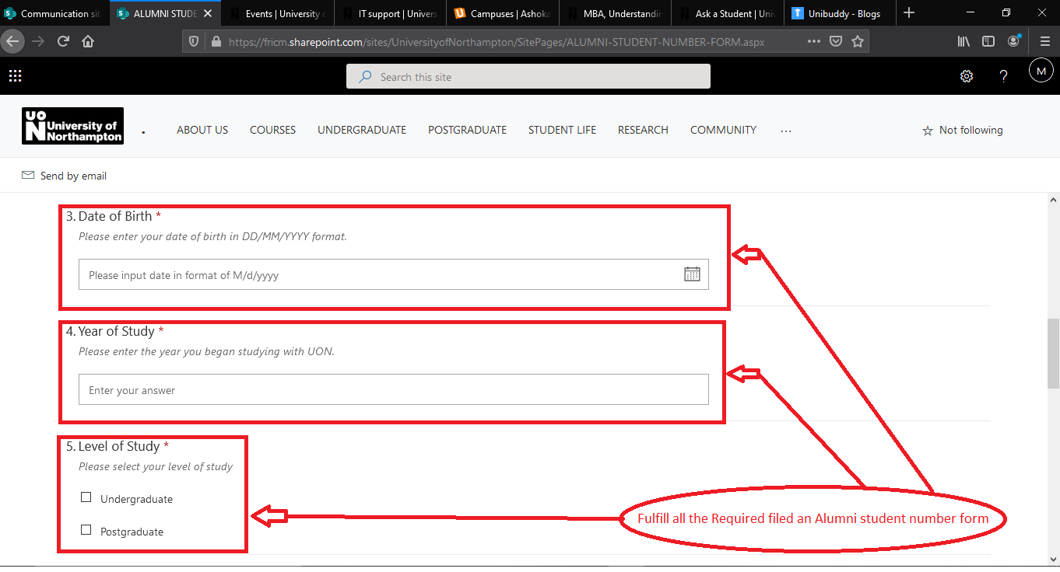

**Figure:**  Fulfill all the Requirements form.

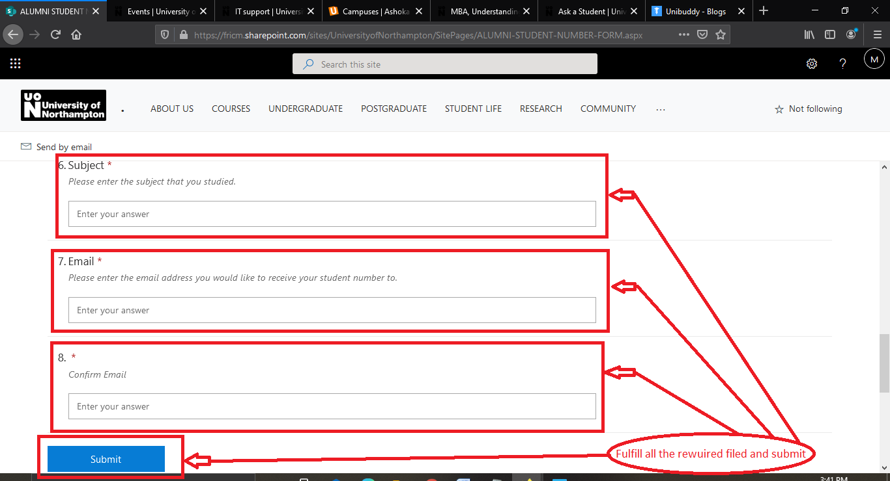

**Figure:**  Fulfill all the Requirements form and Click the submit button.

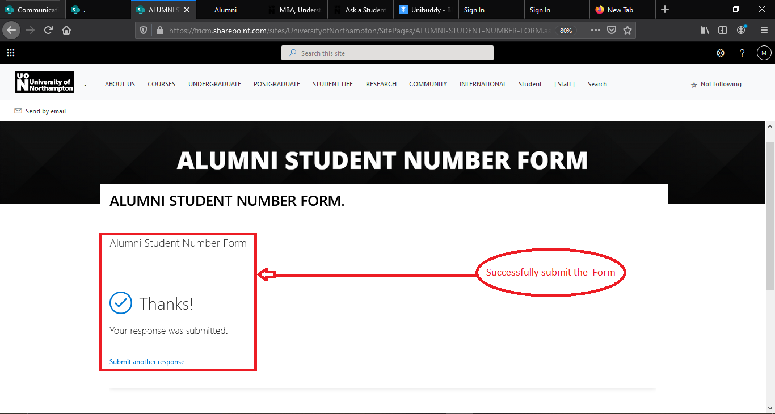

**Figure:**  Successfully submit the form has been show.

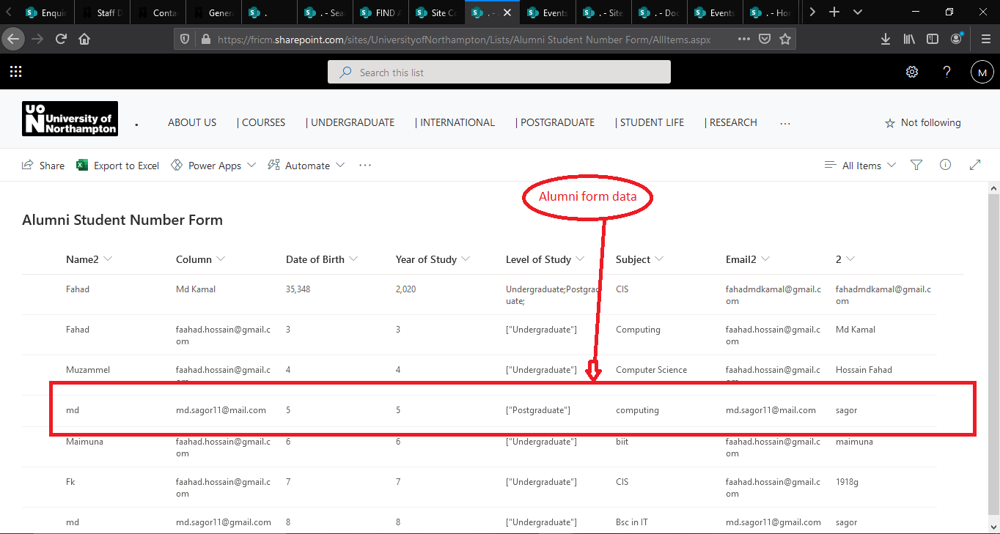

**Figure:**  The alumni student number form data has been save.

**Functional Test- 2**

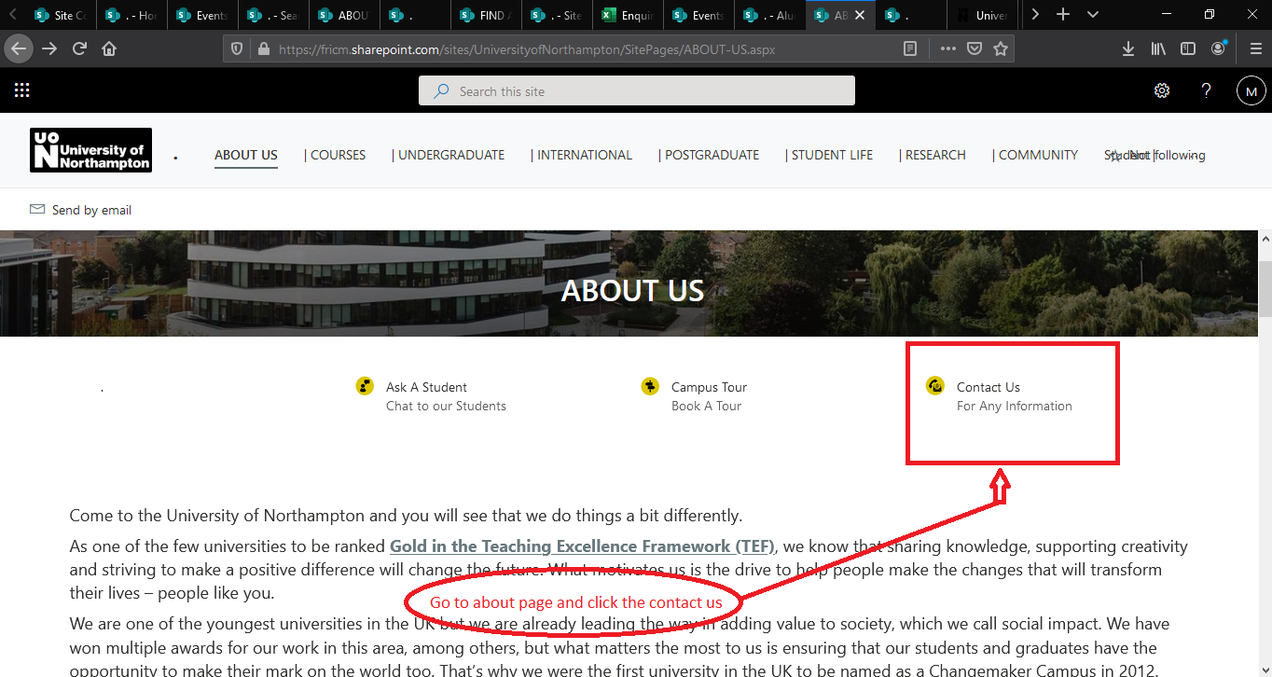

**Figure:**  Go to about us page and click the contact us.

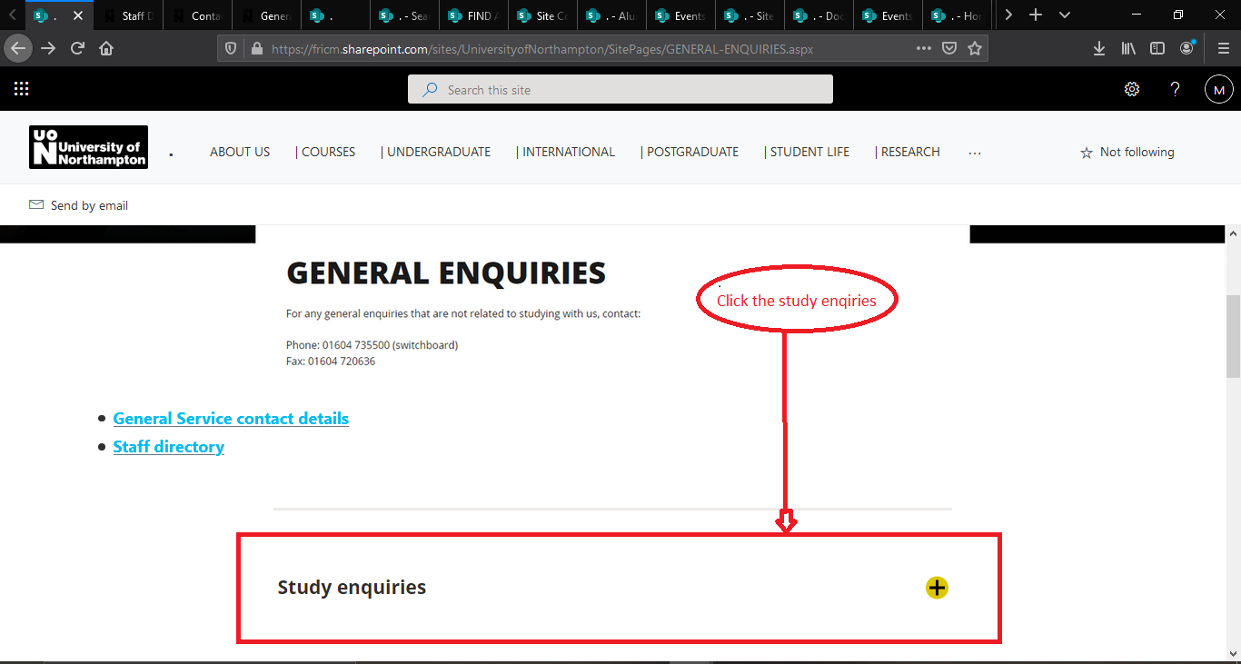

**Figure:**  Now click the study enquiries.

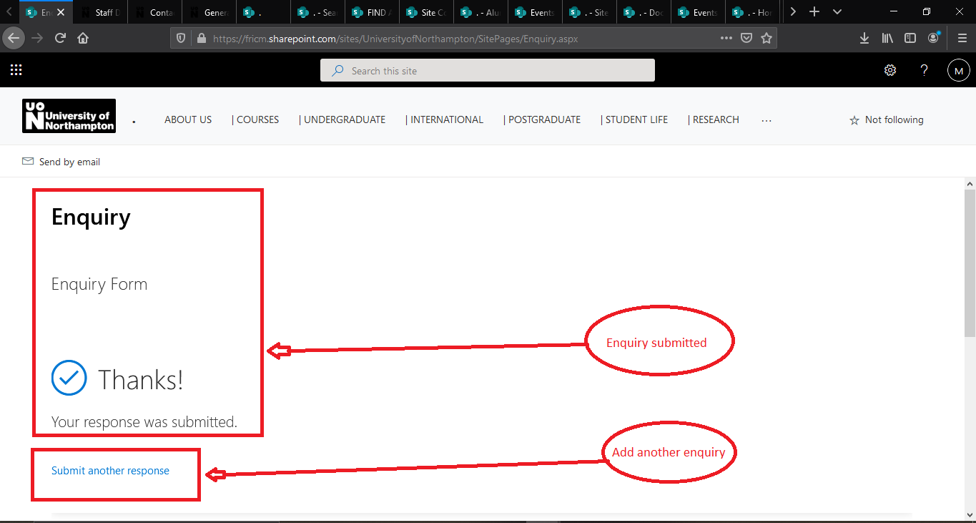

**Figure:**  Successfully submit the form and can submit another enquiry.

|  |  |  |  |  |  |
| --- | --- | --- | --- | --- | --- |
| **Test ID** | **Name of test** | **Description** | **Outcome** | **Actual Result** | **Result** |
| 3 | Function Testing | Testing the accuracy of functionality of the system has required | According the requirements the Functions has work perfectly | Conformation of accepted the form. Conformation of accepted the form. | PASSED |

**4. Usability Test**

**Usability Test- 1**

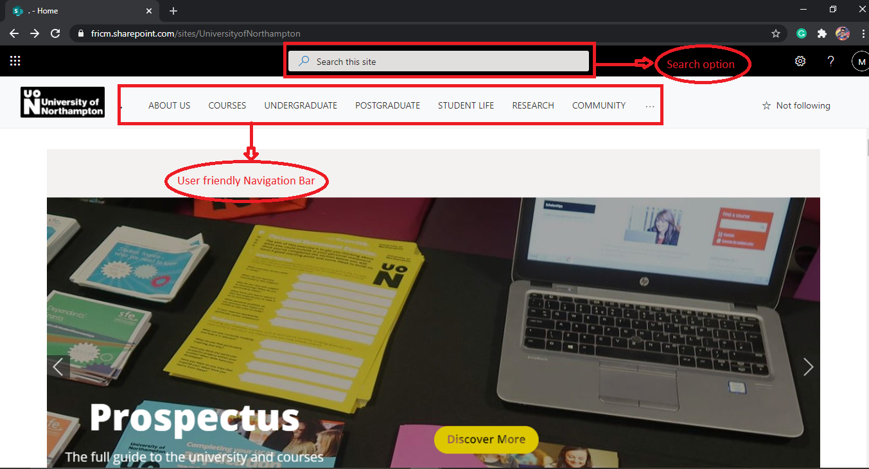

**Figure:**  User-friendly navigation Bar and search option

**Usability Test- 2**

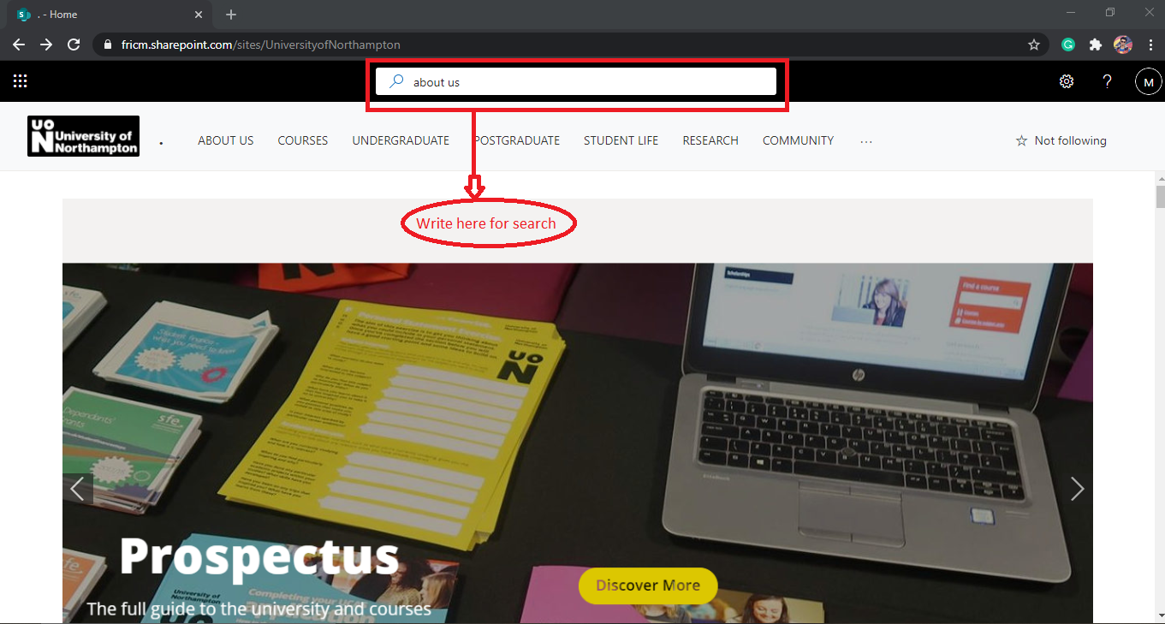

**Figure:**  In search option search about us page.

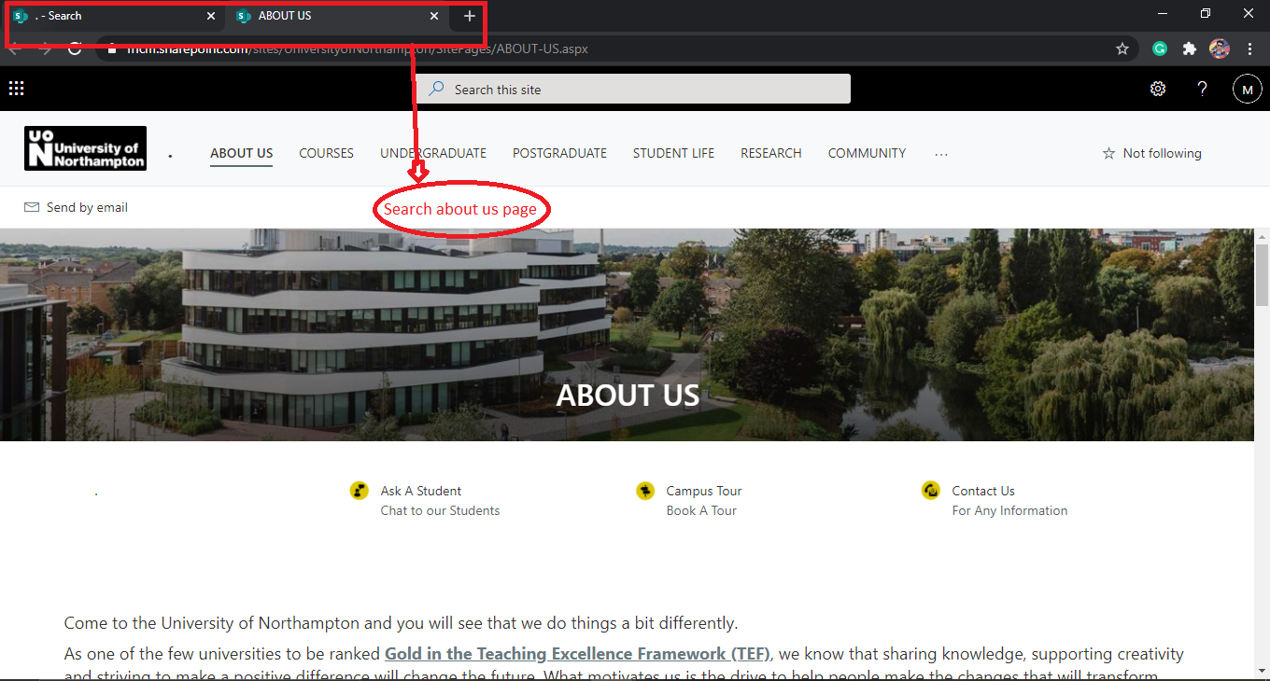

**Figure:**  searching result about us page.

**Usability Test- 3**

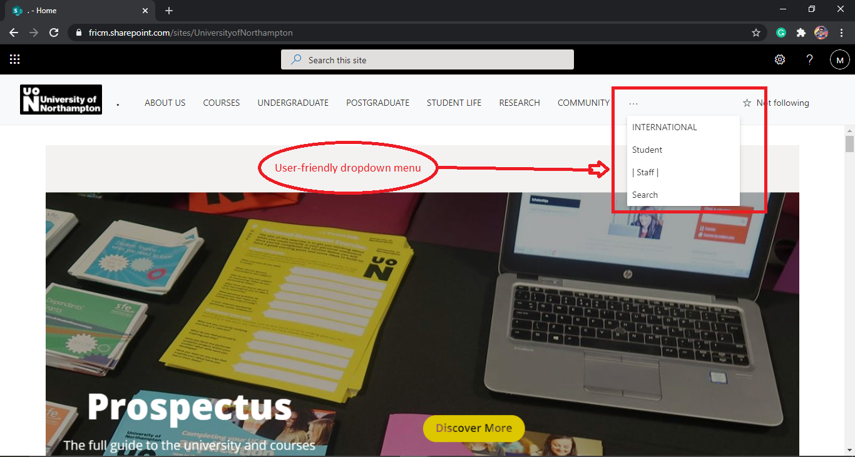

**Figure:**  User-friendly dropdown menu.

|  |  |  |  |  |  |
| --- | --- | --- | --- | --- | --- |
| **Test ID** | **Name of test** | **Description** | **Outcome** | **Actual Result** | **Result** |
| 4 | Usability test | Testing how easy a user complete a task in the system | The control of the whole system was easy. | In usability testing time those feature has been work properly. No usability error was being found. | PASSED |

**5. Security test**

**Authentication test**

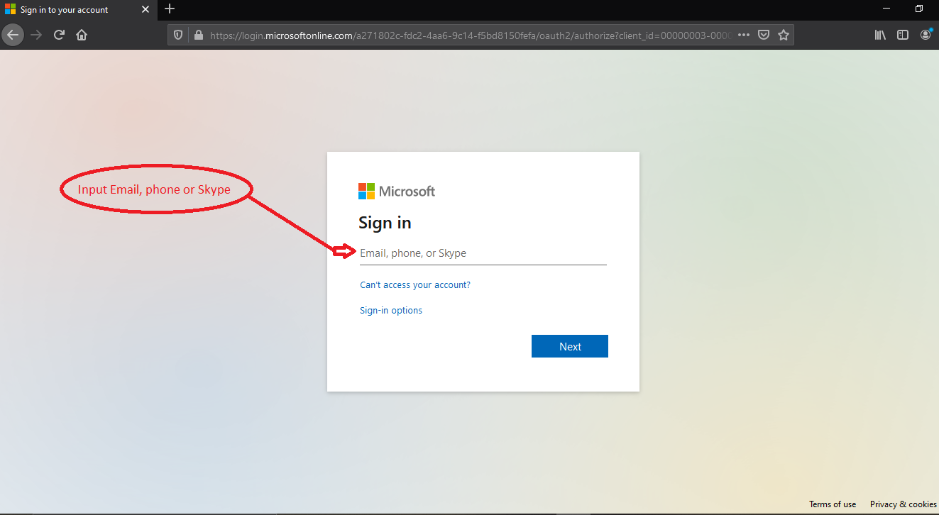

**Figure:** Without genuine email id user will not access the system.

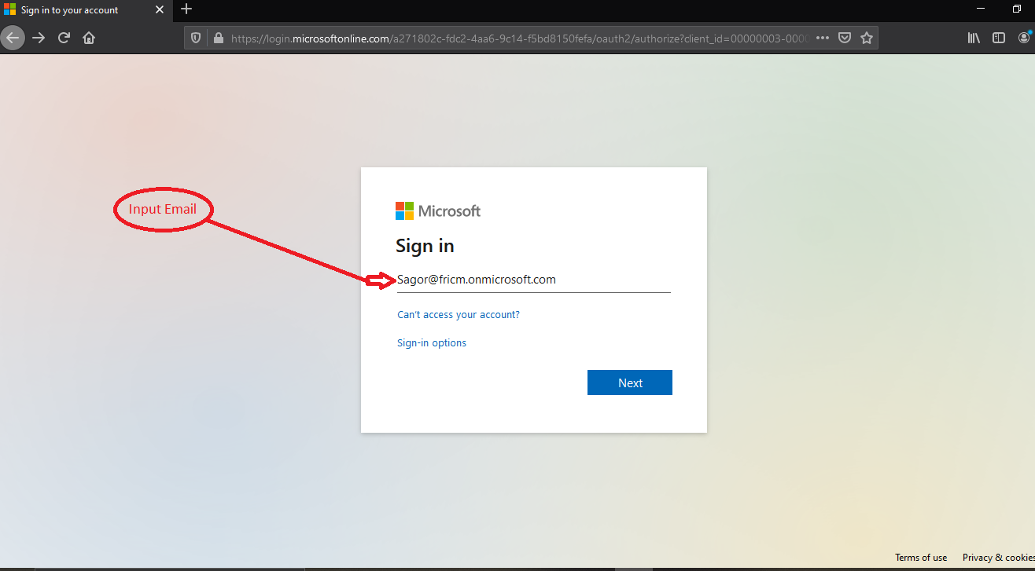

**Figure:** input the genuine email id.

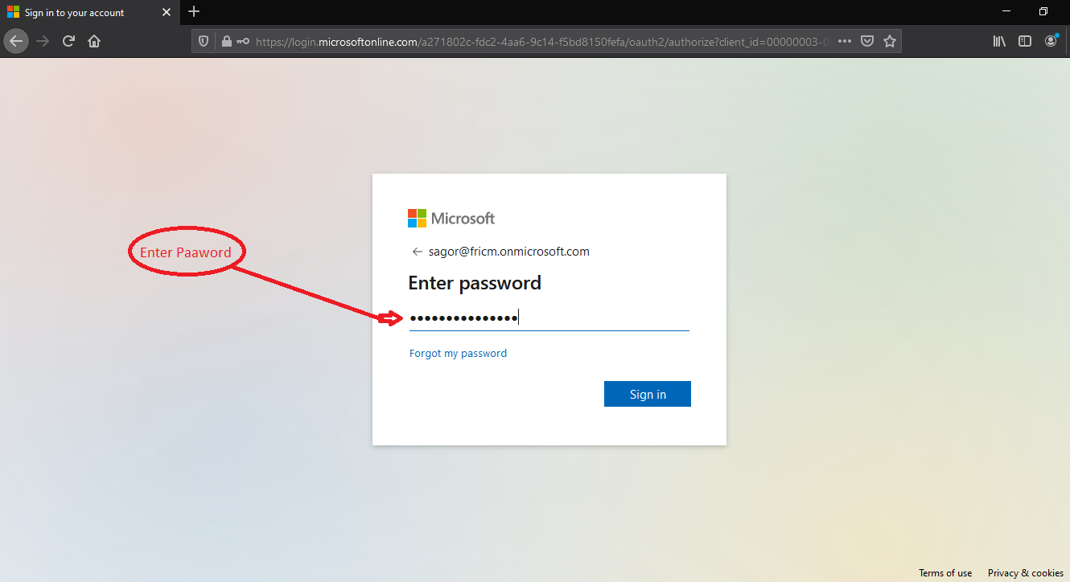

**Figure:** input the genuine password for login.

**Checking of URL**

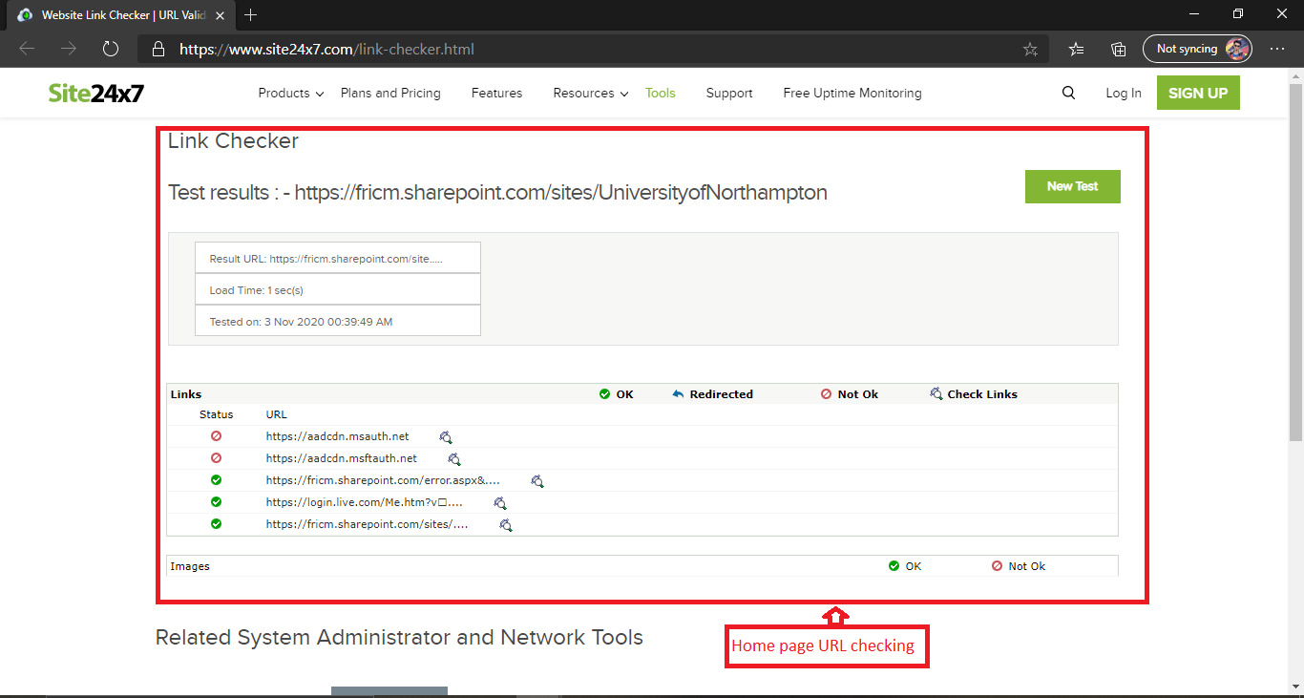

**Figure:** Checking URL on home page.

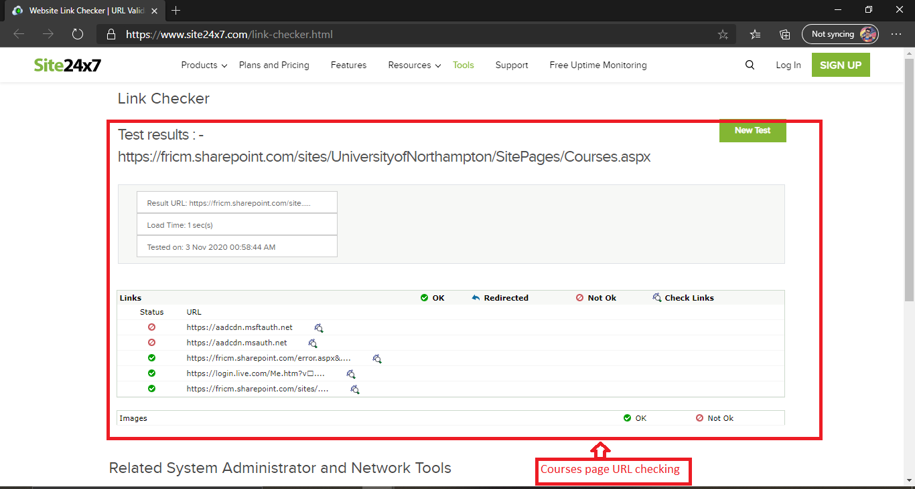

**Figure:** Checking URL on Courses page.

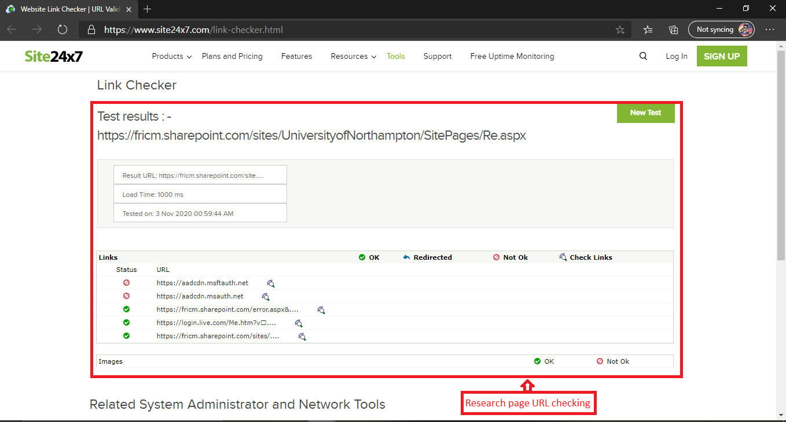

**Figure:** Checking URL on Research page.

|  |  |  |  |  |  |
| --- | --- | --- | --- | --- | --- |
| **Test ID** | **Name of test** | **Description** | **Outcome** | **Actual Result** | **Result** |
| 5 | Security test | Test is there any security threats have in the system. | The whole system security was been well enough | Successfully login and access the system. URL checking result was positive. | PASSED |

**6. Browser Compatibility Testing**

**Browser Compatibility Testing- 1**

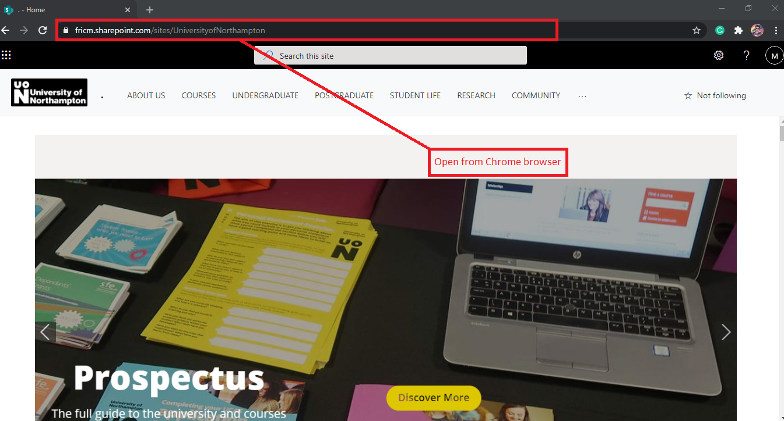

**Figure:** Open from chrome browser

**Browser Compatibility Testing- 2**

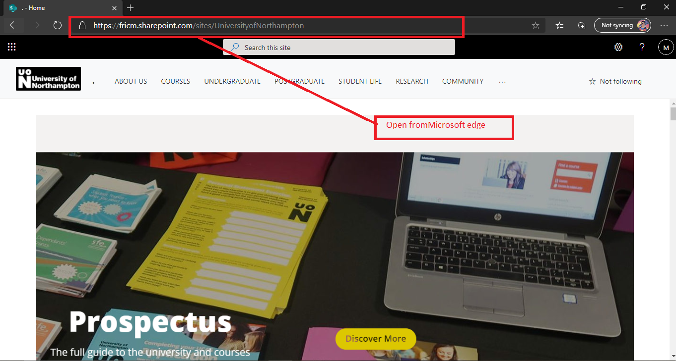

**Figure:** Open from Microsoft edge browser.

**Browser Compatibility Testing- 3**

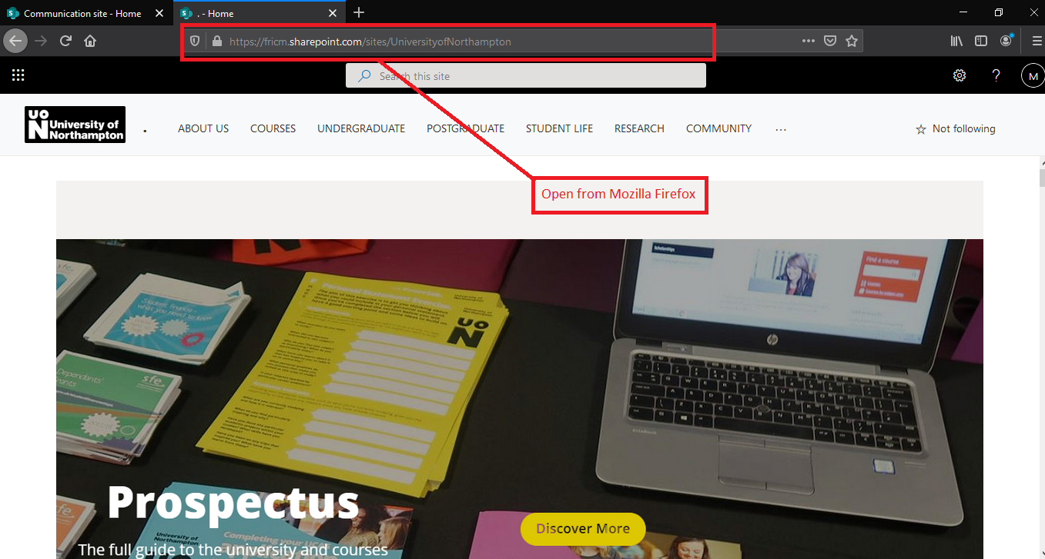

**Figure:** Open from Mozilla Firefox browser.

|  |  |  |  |  |  |
| --- | --- | --- | --- | --- | --- |
| **Test ID** | **Name of test** | **Description** | **Outcome** | **Actual Result** | **Result** |
| 6 | Browser compatibility test | Running the system in different browser platform | The system was perfectly run in every different browser platform | In during testing time the website did not incurred any problem in different browser. | PASSED |

**7. Responsive Test**

**Responsive Test- 1**

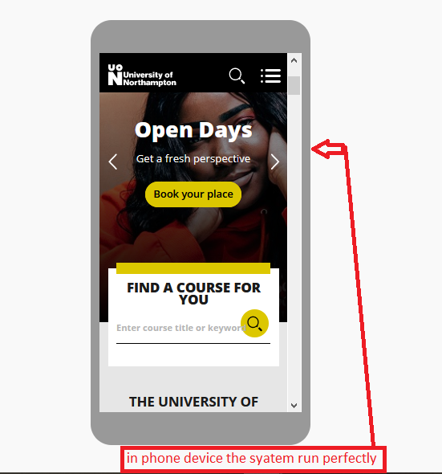

**Figure:** Responsive the system in phone.

**Responsive Test- 2**

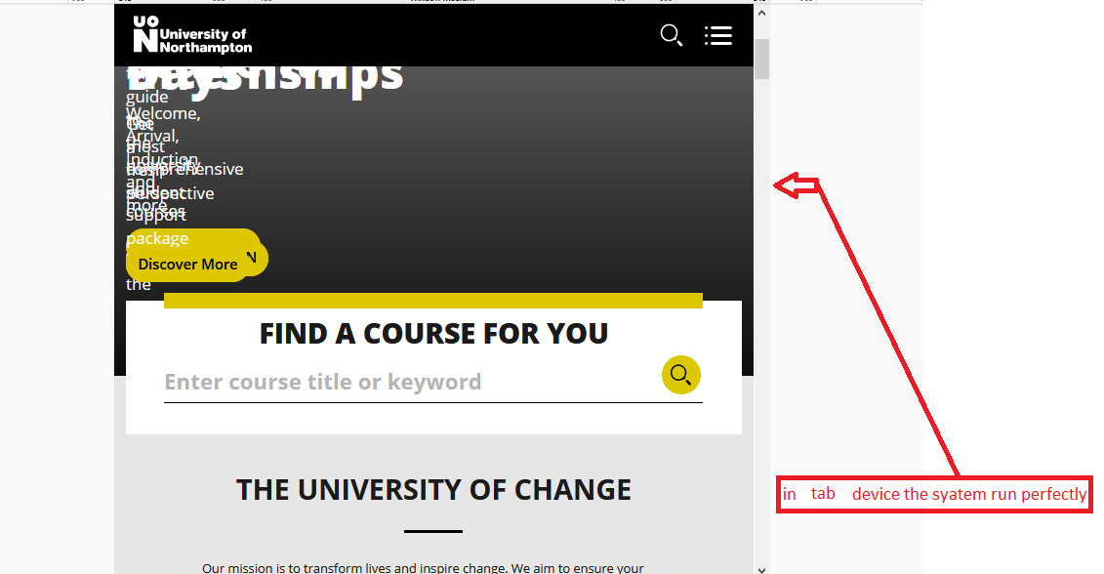

**Figure:** Responsive the system in tab.

|  |  |  |  |  |  |
| --- | --- | --- | --- | --- | --- |
| **Test ID** | **Name of test** | **Description** | **Outcome** | **Actual Result** | **Result** |
| 7 | Responsive Testing | Test runs the website in different device. | The website should be run perfectly in possible different device. | In testing time there was no significant change in different device viewing angle. | PASSED |